**BIOINFORMATICS ASSIGNMENT 1 (Day 1 - 5)**

***Note: You will be added in a slack community of Bversity for further doubts and communications***

1. Gene Name: TP53 Danio rerio(zebra fish)

2. Function of the Gene: >>> Its function is controlling the cell cycle progression, cellular >>> it is required for normal cell proliferation and prevention of tumors formation .it is also involved in enabling DNA binding transcription factor ability ,identical protein ability and apoptosis signalling pathway in response to dna damage

3. NCBI accession number: NC_007116.7:24086227-24097807 Danio rerio strain Tuebingen chromosome 5, GRCz11 Primary Assembly

4. Forward Primer: TGCTTGATTTTGCCGTTGGG

5. Reverse primer: ACGCCGAATCTCACGCATAT

6. Features of primers:

Primer Size Min

18

Opt

20

Max

23

Primer Tm Min

57.0

Opt

60.0

Max

63.0

Max Tm Difference

5.0

Table of thermodynamic parameters

SantaLucia 1998

Product Tm Min

-1000000.0

Opt

0.0

Max

1000000.0

Primer GC% Min

30.0

Opt

50.0

Max

70.0

Product Size Ranges

150-250 100-300 301-400 401-500 501-600 601-700 701-850 851-1000

Number To Return

5

Max 3' Stability

9.0

Max Library Mispriming

12.00

Pair Max Library Mispriming

2

0.00

7. Amplicon length and sequence:

Amplicon sequence:

TGATTTTGCCGTTGGGTTTTCCATT

AGCATAGTCATTAGCATATTCATACGGGGGAGGAGGCAGGGAGGGGTTTTGTGCTCGTGC

ATGTTGCGCTCAGTTTCACGTTCATTCAGATGTACAAAAGAATATGCGTGAGATTCGGCG

Amplicon length:150 bp

**qPCR Data analysis (DAY 5)**

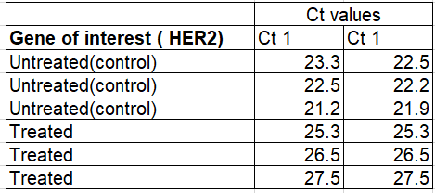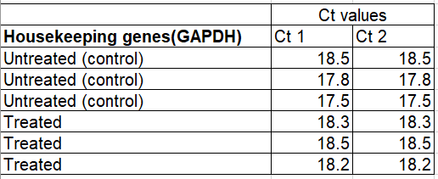

The following data are results of qPCR from cancer cell lines. HER2 stands for human epidermal growth factor. It’s healthy in normal amounts, but too much may be a sign of a certain type of breast cancer. Calculate the 2 Delta Ct values for the following data and plot the values on a graph using graphpad prism.

